

Final project report

**Submitted to: sir Manzoor Ilahi Tamimy & ma’am Sadia khan**

**COMSATS University Islamabad**

2022

Programming fundamentals (CSC103)

**Submitted by: Hassan (FA21-BAI-009)**

I made a student registration system for the management team at an educational institute

My program performs the following functionalities:

1. It has a login system with all the appropriate checks.
2. If user input invalid login info it will show an invalid entry popup screen.
3. Then if login info is correct it takes user to the main screen
4. Here it will give user 3 option (1: enrol, 2: update, 3: search).
5. Now user can enter data of student in enrol
6. He can update the data about the students that is stored in a file.
7. Or he can search for student data using there registration number.

**Task:** make a project using java swings library that uses file handling and exception handling.

Requirements:

1. Data should be taken from the user by the means of graphical user interface.
2. That data must be stored (write) in a text file.
3. The program must include a module or functionality that enables the user to read the data stored in the text file and update it.

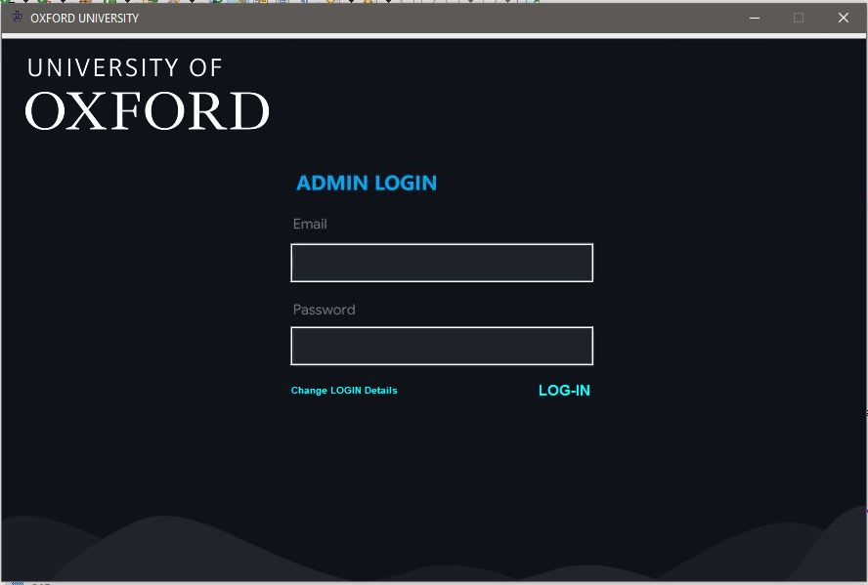

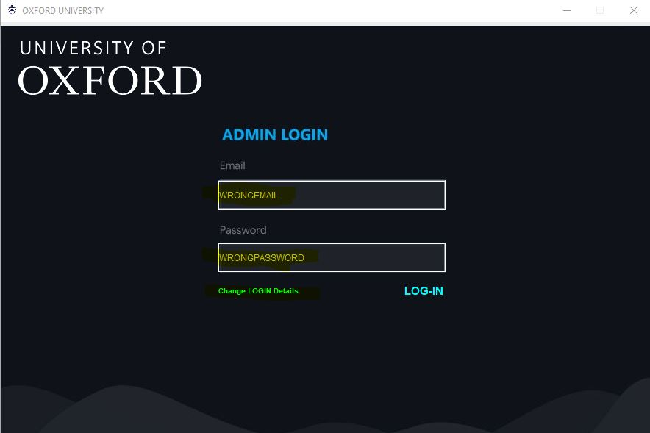

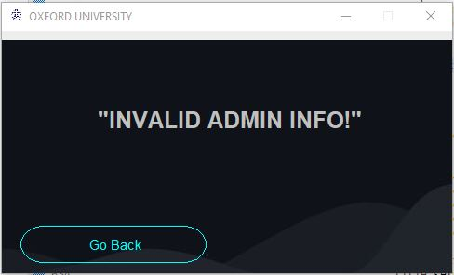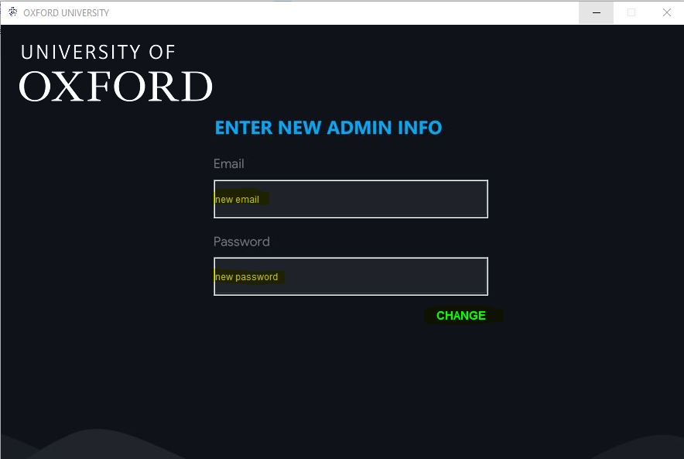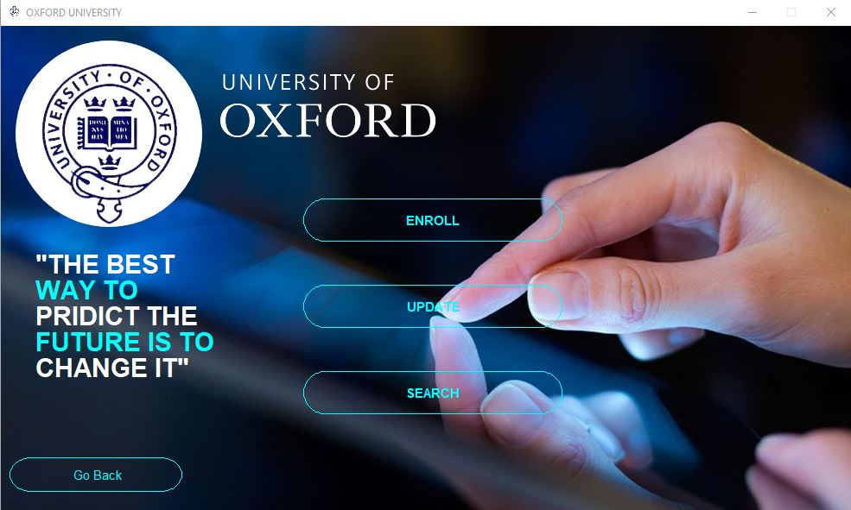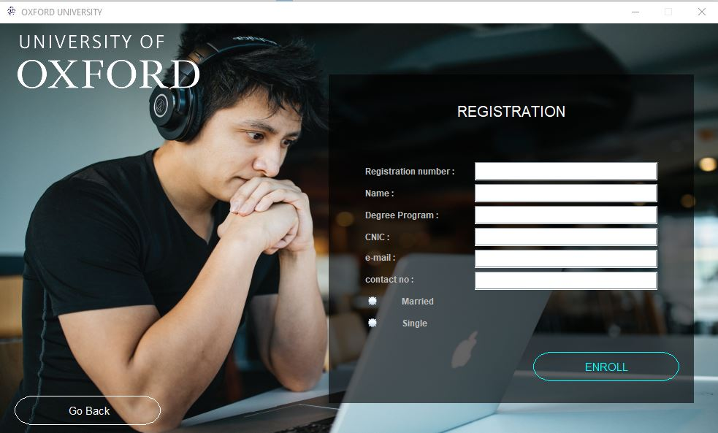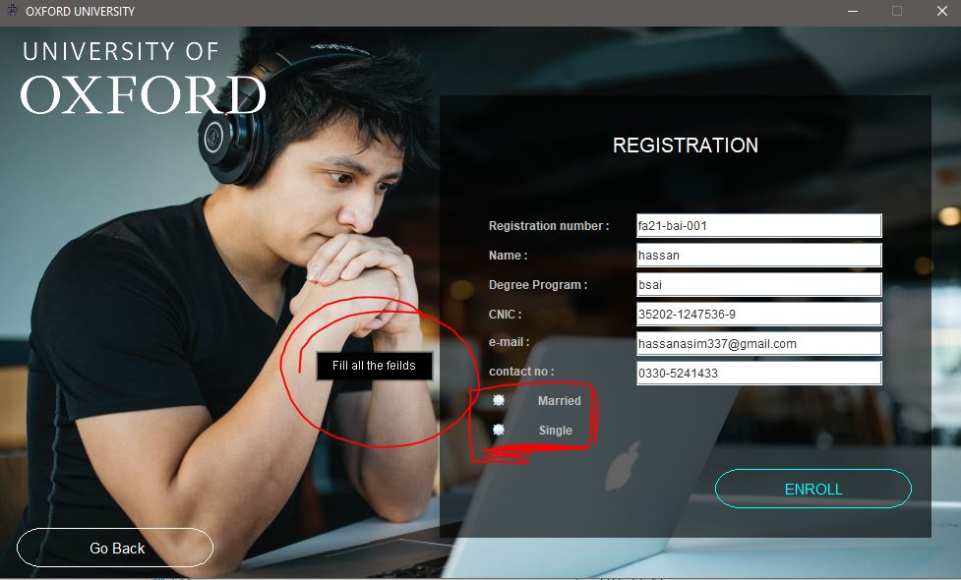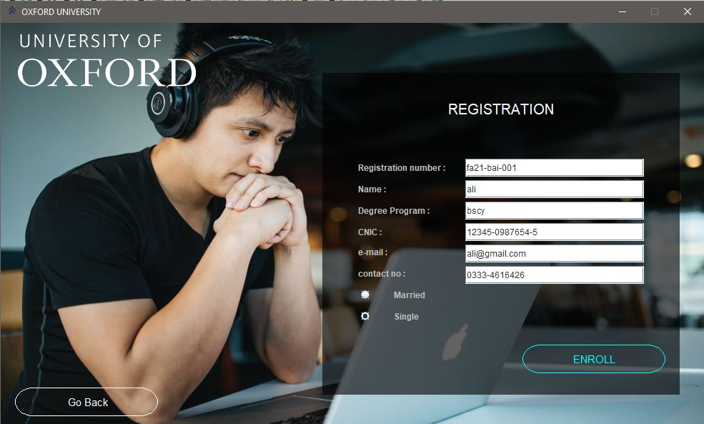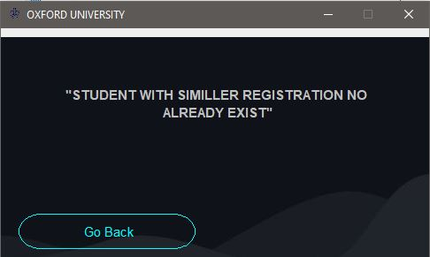



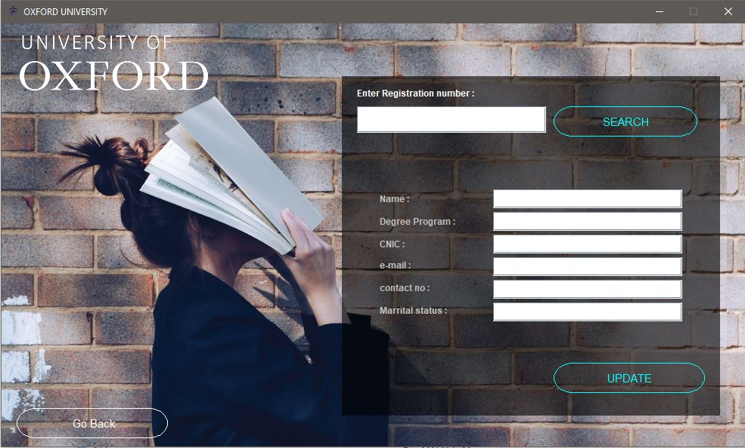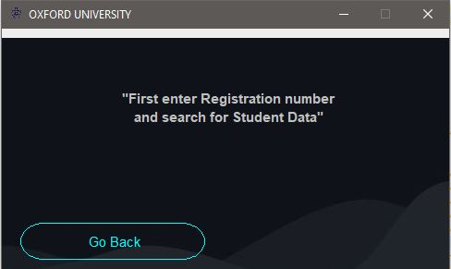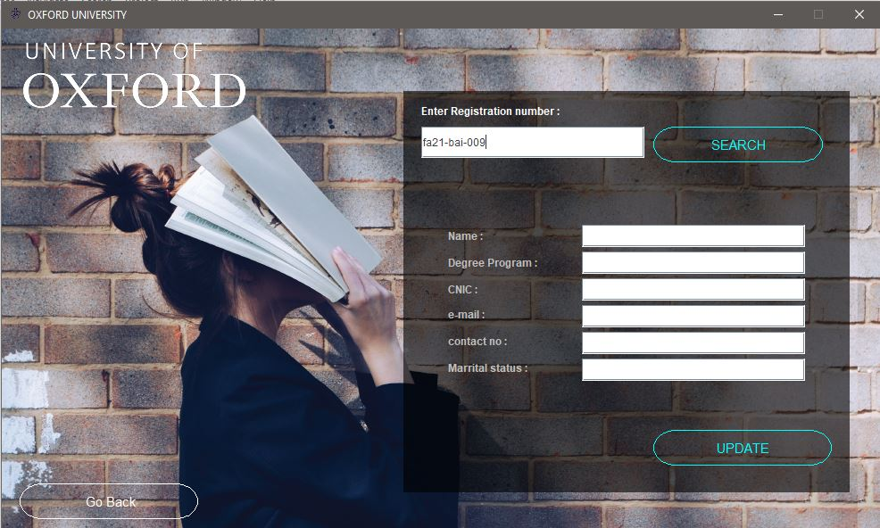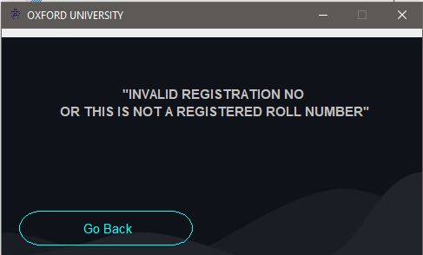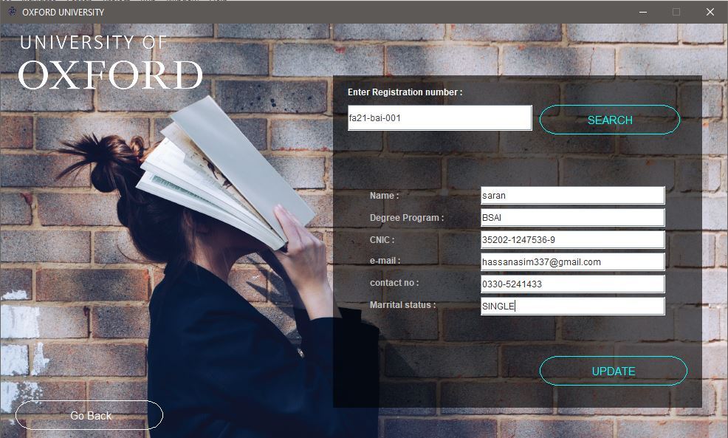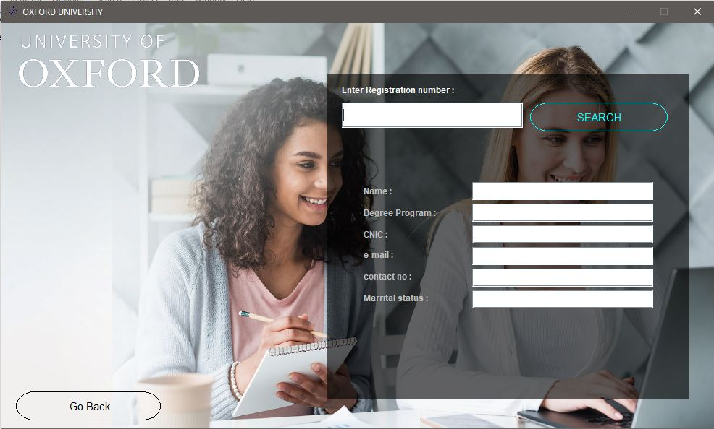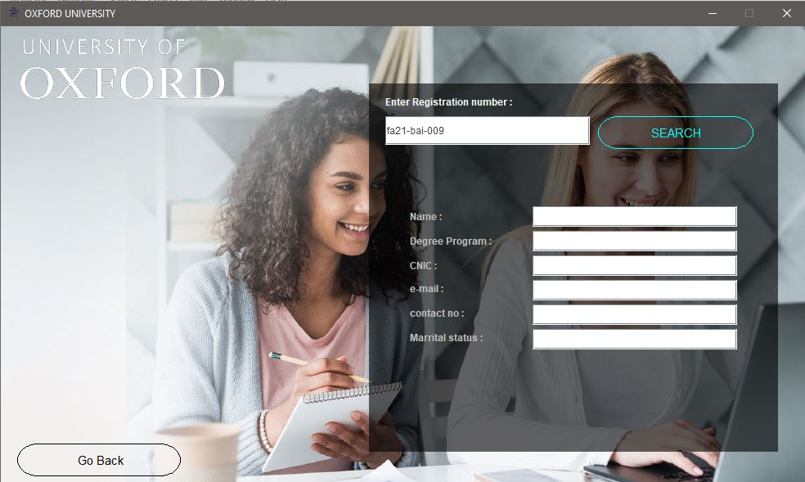

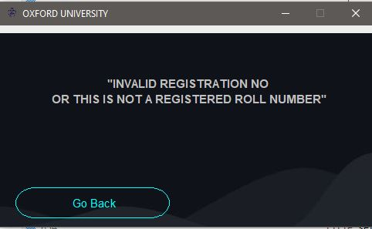

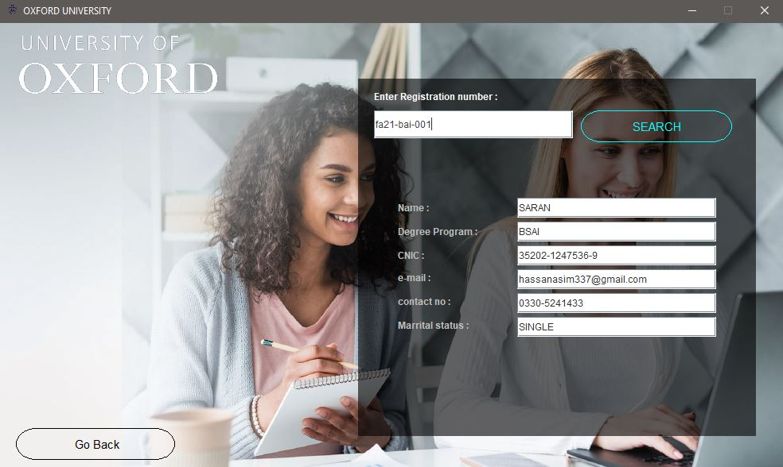

***All the pictures are the output screen of my application respectively***

***If any query, contact me at*** *hassanasim337@gmail.com*